Goose Creek Transit
Sheridan’s Public Bus Transportation
“Let’s Go!”
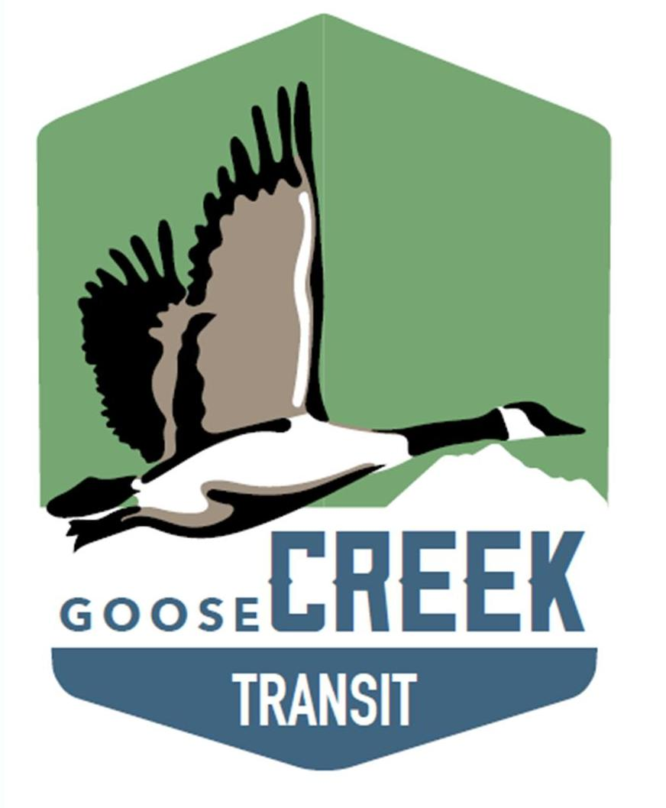

Effective – January 5th, 2026

TO and FROM - Buffalo, WY

Goose Creek Transit is in collaboration with Buffalo Area Transit System (BATS)

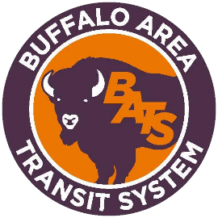

GOING TO Buffalo from Sheridan?

Buffalo Area Transit System (BATS) will depart The Hub on Smith at 9:00am, Monday, Wednesday and Friday’s and departs Buffalo Senior Center at 1:00pm returning to The Hub on Smith at 2:00pm. Please be on time.
Step 1 – Call BATS, 24-hours in advance at: 307-684-9554 to inquire their availability
Step 2 – Call Goose Creek Transit, 24-hours in advance at: 307-675-7433 to inquire our availability

Continue on next page

GOING TO Sheridan from Buffalo?

Buffalo Area Transit System (BATS) will depart the Buffalo Senior Center at 7:30am, Monday, Wednesday and Friday’s and arrives at The Hub on Smith at 9:00am. At 2:00pm, BATS will depart The Hub on Smith for Sheridan County Airport, then to Buffalo. Please be on time.
Step 1 – Call BATS, 24-hours in advance at: 307-684-9554 to inquire their availability
Step 2 – Call Goose Creek Transit, 24-hours in advance at: 307-675-7433 to inquire our availability

Capacity:

7 – Ambulatory riders
2 Bag Limit – For groceries, etc.
1 – Non-ambulatory (wheelchair) rider

Continue on next page
Fares:

Buffalo Area Transit System (BATS):
- One-Way — $8.00 - (to/from Sheridan)
- Round-Trip — $16.00 - (to/from Sheridan)
- Pass - $75.00 — This includes 10 one-way passes (to/from Sheridan)
- One-Way - $1.00 — (inside City of Buffalo)
Goose Creek Transit:
- One-Way – Over 60 yrs. – $3.50 – (inside City of Sheridan)
- One-Way – Under 60 yrs. – $5.50 – (inside City of Sheridan)
- Book of Tickets – Over 60 yrs. – $30.00 – This includes 10 one-way passes – (inside City of Sheridan)
- Book of Tickets – Under 60 yrs. – $50.00 – This includes 10 one-way passes – (inside City of Sheridan)
- Free Rides to the following destinations:
  - Walmart
  - Albertsons
  - Ridleys
  - First Federal Bank

Information:

Goose Creek Transit - 307-675-7433
https://thehubsheridan.org/services/goose-creek-transit/

Buffalo Area Transit System (BATS)
Gary or Jan – 307-684-9554 – https://www.wybats.com

