SUNDAY | MONDAY | TUESDAY | WEDNESDAY | THURSDAY | FRIDAY | SATURDAY
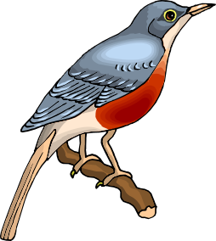 | 1  7-9 Coffee & Socialization  9-10 HDM Trays/Volunteer  10-12 “8 Balls of Fire”  10-12 Small Groups  12-12:45 Lunch  12:25-1:30 Horseshoes  1:30-2:30 Trivia War  2:30-5 Snack & Large Group | 2  7-9 Coffee/Current Events  9-10 Dominoes  10-11:15 Small Groups  11:15-12:30 Lunch/Bingo  12:30-1:30 Horseshoes  1:30-2:30 Baseball  2:30-5 Snack & Large Group | 3  7-9 Coffee & Cards  9-10 HDM Trays/Volunteer  10-11 Trivia War  11-12 Horseshoes  12-1 Lunch  1-3:30 Brain/Active Games  2:30-5 Snack & Large Group | 4  7-9 Coffee & Socialization  9-10 DDP Yoga  10-11 Active Game  11-12:30 Lunch  12:30-1:30 Horseshoes  1:30-2:30 Bingo w/fabulous prizes  2:30-5 Snack & Large Group | 5  7-9 Coffee & Cards  9-10 Crossword Challenge  10-11:15 Active Game  11:12-12:30 Lunch/Bingo  12:30-1:30 Horseshoes  1:30-2:30 Baseball  2:30-5 Snack & Large Group | 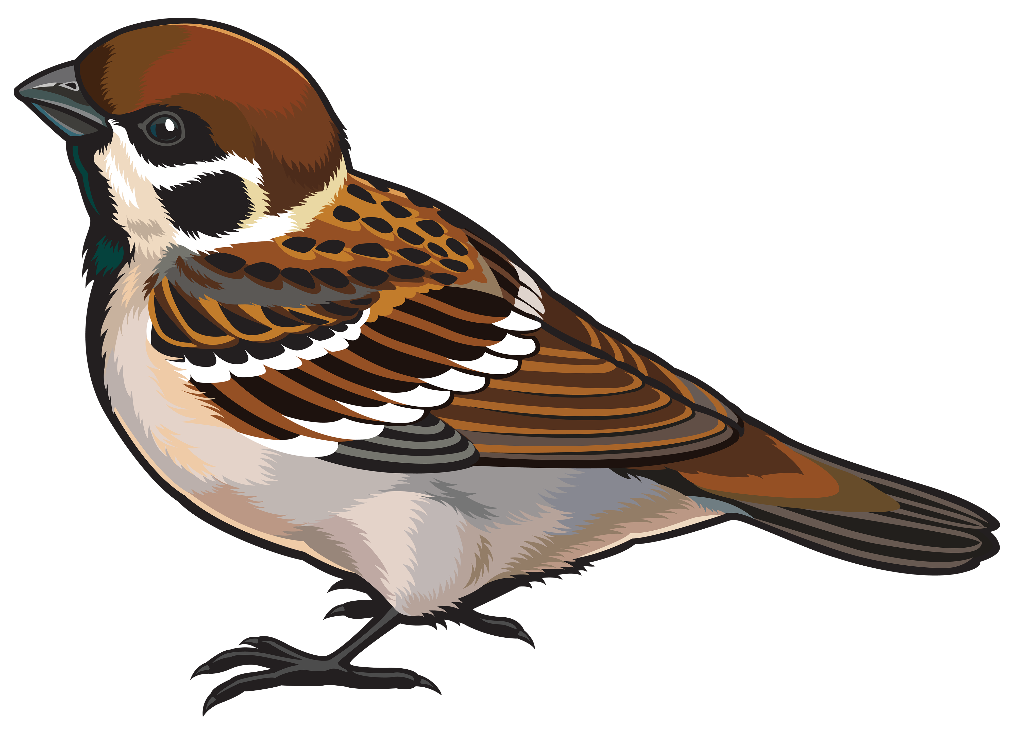
 | 8  7-9 Coffee & Socialization  9-10 HDM Trays/Volunteer  10-12 “8 Balls of Fire”  10-12 Small Groups  12-12:45 Lunch  12:25-1:30 Horseshoes  1:30-2:30 Jingo  2:30-5 Snack & Large Group | 9  7-9 Coffee/Current Events  9-10 Dominoes  10-11:15 Small Groups  11:15-12:30 Lunch/Bingo  12:30-1:30 Horseshoes  1:30-2:30 Tailgate Toss  2:30-5 Snack & Large Group | 10  7-9 Coffee & Cards  9-10 HDM Trays/Volunteer  10-11 Trivia War  11-12 Horseshoes  12-1 Lunch  1-2:30 Baseball  2:30-5 Snack & Large Group | 11  7-9 Coffee & Socialization  9-10 DDP Yoga  10-11 Active Game  11-12:30 Lunch  12:30-1:30 Horseshoes  1:30-2:30 Bingo w/fabulous prizes  2:30-5 Snack & Large Group | 12  7-9 Coffee & Cards  9-10 Crossword Challenge  10-11:15 Active Game  11:12-12:30 Lunch/Bingo  12:30-1:30 Horseshoes  1:30-2:30 Outburst  2:30-5 Snack & Large Group
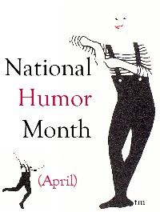 | 15  7-9 Coffee & Socialization  9-10 HDM Trays/Volunteer  10-12 “8 Balls of Fire”  10-12 Small Groups  12-12:45 Lunch  12:25-1:30 Horseshoes  1:30-2:30 Famous Faces  2:30-5 Snack & Large Group | 16  7-9 Coffee/Current Events  9-10 Dominoes  10-11:15 Small Groups  11:15-12:30 Lunch/Bingo  12:30-1:30 Horseshoes  1:30-2:30 baseball  2:30-5 Snack & Large Group | 17  7-9 Coffee & Cards  9-10 HDM Trays/Volunteer  10-11 Trivia War  11-12 Horseshoes  12-1 Lunch  1-2:30 Brain/Active Games  2:30-5 Snack & Large Group | 18  7-9 Coffee & Socialization  9-10 DDP Yoga  10-11 Active Game  11-12:30 Lunch  12:30-1:30 Horseshoes  1:30-2:30 Bingo w/fabulous prizes  2:30-3 Exercise  2:30-5 Snack & Large Group | 19  7-9 Coffee & Cards  9-10 Crossword Challenge  10-11:15 Active Game  11:12-12:30 Lunch/Bingo  12:30-1:30 Horseshoes  1:30-2:30 Baseball  2:30-5 Snack & Large Group  High Five Day | Small Groups will focus on the interests of those in the group such as cards, dominoes, trivia, crosswords, jigsaw puzzles, wii bowling, scrabble, walking, etc.
 | 22  7-9 Coffee & Socialization  9-10 HDM Trays/Volunteer  10-12 “8 Balls of Fire”  10-12 Small Groups  12-12:45 Lunch  12:25-1:30 Horseshoes  1:30-2:30 Eye Know  2:30-5 Snack & Large Group | 23  7-9 Coffee/Current Events  9-10 Dominoes  10-11:15 Small Groups  11:15-12:30 Lunch/Bingo  12:30-1:30 Horseshoes  1:30-2:30 Tailgate Toss  2:30-5 Snack & Large Group | 24  7-9 Coffee & Cards  9-10 HDM Trays/Volunteer  10-11 Baseball  11-12 Horseshoes  12-1 Lunch  1-2:30 Brain/Active Games  2:30-5 Snack & Large Group  Pig in A Blanket Day | 25  7-9 Coffee & Socialization  9-10 DDP Yoga  10-11 Active Game  11-12:30 Lunch  12:30-1:30 Horseshoes  1:30-2:30 Bingo w/fabulous prizes  2:30-5 Snack & Large Group | 26  7-9 Coffee & Cards  9-10 Crossword Challenge  10-11:15 Active Game  11:12-12:30 Lunch/Bingo  12:30-1:30 Horseshoes  1:30-2:30 Outburst  2:30-5 Snack & Large Group | Active Games will be fun and challenging. Available games include horseshoes, Washers, Blongo-ball, Bean Bag Toss, Shuffleboard, Broomball, Volleyball, etc.
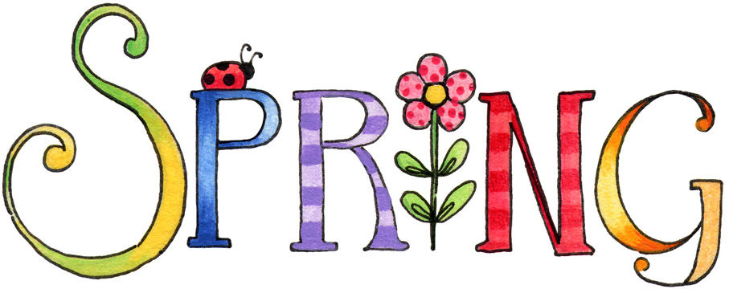 | 29  7-9 Coffee & Socialization  9-10 HDM Trays/Volunteer  10-12 “8 Balls of Fire”  10-12 Small Groups  12-12:45 Lunch  12:25-1:30 Horseshoes  1:30-2:30 Trivia Was  2:30-5 Snack & Large Group | 30  7-9 Coffee/Current Events  9-10 Dominoes  10-11:15 Small Groups  11:15-12:30 Lunch/Bingo  12:30-1:30 Horseshoes  1:30-2:30 Baseball  2:30-5 Snack & Large Group | 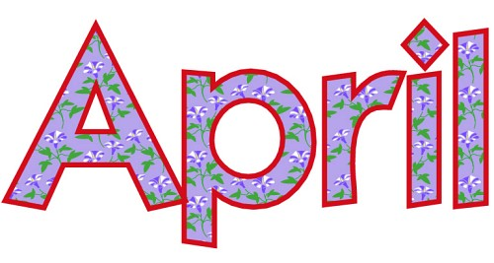 |  |  | 

